The hotel has three floors; in the first floor there three departments (Reception, store and Logistics), in the second floor there are three departments (Finance, HR and Sales/Marketing), while the third floor hosts the IT and Admin. Therefore, the following are part of the considerations during the design and implementation;

1. There should be three routers connecting each floor (all placed in the server room in IT department).
2. All routers should be connected to each other using serial DCE cable.
3. The network between the routers should be 10.10.10.0/30,10.10.10.4/30 and 10.10.10.8/30.
4. Each floor is expected to have one switch (placed in the respective floor).
5. Each floor is expected to have WIFI networks connected to laptops and phones.
6. Each department is expected to have a printer.
7. Each department is expected to be in different VLAN with the following details;

1st Floor;

- Reception- VLAN 80, Network of 192.168.8.0/24

- Store- VLAN 70, Network of 192.168.7.0/24

- Logistics- VLAN 60, Network of 192.168.6.0/24

2nd Floor;

- Finance- VLAN 50, Network of 192.168.5.0/24

- HR- VLAN 40, Network of 192.168.4.0/24

- Sales- VLAN 30, Network of 192.168.3.0/24

3rd Floor;

- Admin- VLAN 20, Network of 192.168.2.0/24

- IT- VLAN 10, Network of 192.168.1.0/24

1. Use OSPF as the routing protocol to advertise routes.
2. All devices in the network are expected to obtain IP address dynamically with their respective router configured as the DHCP server.
3. All the devices in the network are expected to communicate with each other.
4. Configure SSH in all the routers for remote login.
5. In IT department, add PC called Test-PC and use it to test remote login.
6. Configure port security to IT-department switch to allow only Test-PC to access port (use sticky method to obtain mac-address with violation mode of shutdown.)

Technologies Implemented

* Creating a network topology using Cisco Packet Tracer.
* Hierarchical Network Design.
* Connecting Networking devices with Correct cabling.
* Creating VLANs and assigning ports VLAN numbers.
* Subnetting and IP Addressing.
* Configuring Inter-VLAN Routing (Router on a stick).
* Configuring DHCP Server (Router as the DHCP Server).
* Configuring SSH for secure Remote access.
* Configuring switchport security or Port-Security on the switches.
* Configuring WLAN or wireless network (Cisco Access Point).
* Host Device Configurations.
* Test and Verifying Network Communication.

Analyzing the Case Study we’ve been given

* First floor: 3 department(Reception, Logistics, Store)
* Second floor: 3 department(Finance, HR, Sales/Marketing)
* Third floor: 2 department(Admin, IT)
* 3 Router connecting each floor
* All router should be connected to each with Serial Cable DCE
* Between the network router we should be using 10.10.10.0/30, 10.10.10.4/30 and 10.10.10.8/30.
* Each floor should have 1 switch(3 switch in total)
* Each floor should have WIFI connected to laptop and phones(Access point)
* Each department should have a printer
* Each department expected to be in different VLAN(We’ve been given VLAN details)

1st Floor;

- Reception- VLAN 80, Network of 192.168.8.0/24

- Store- VLAN 70, Network of 192.168.7.0/24

- Logistics- VLAN 60, Network of 192.168.6.0/24

2nd Floor;

- Finance- VLAN 50, Network of 192.168.5.0/24

- HR- VLAN 40, Network of 192.168.4.0/24

- Sales- VLAN 30, Network of 192.168.3.0/24

3rd Floor;

- Admin- VLAN 20, Network of 192.168.2.0/24

- IT- VLAN 10, Network of 192.168.1.0/24

* Use OSPF as the routing protocol to advertise route(OSPF Routing Protocol)
* All device in the network are expected to obtain IP dynamically with their respective Router(DHCP Server)
* Connectivity between all devices are expected to communicate with each other(Inter-VLAN routing)
* Remote login through SSH(SSH, not Telnet since it’s not very secure)
* Add a PC called Test-PC use it to test remote login
* Configure port security to IP department allowing only the Test-PC to access port fa0/1

Step by Step configuration

3x Router 2911

We must configure Serial Port on each Router => Using HWIC-2T Module

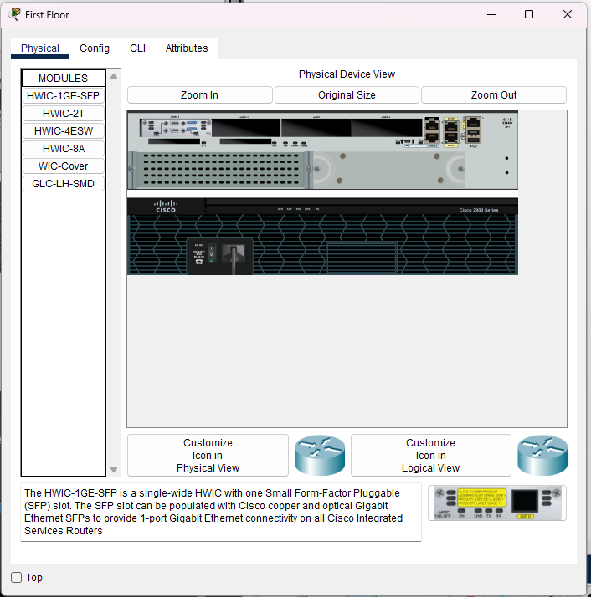

After done configuring all Router to have Serial cable support

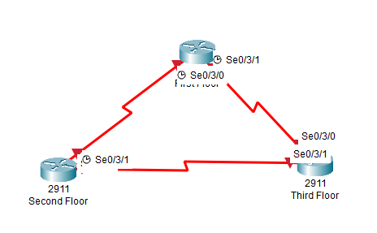

Adding all the Presequisite to the Network Topology such as cabling, devices, access point, SW and Router

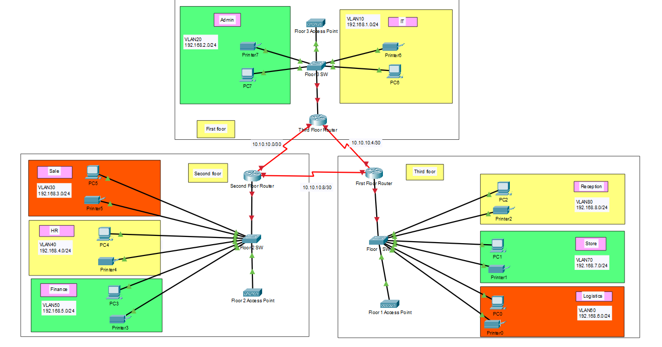

Next step: configuring

If we want them to start using OSPF route, we need to change the clockrate of the Router since it’s using the Serial cable

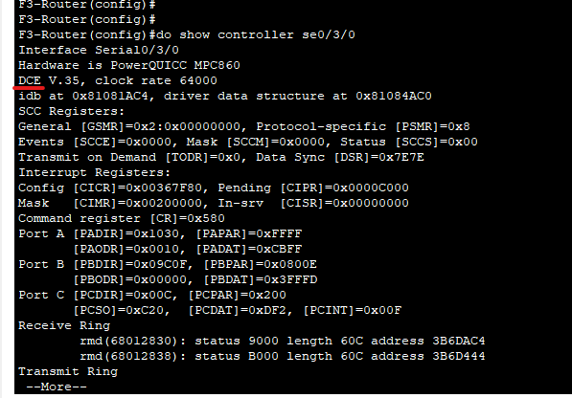

Use command: show controller [interface] => To check DCE interface so we can change the clock rate of each interface

Floor 3 and Floor 2 both have DCE cable, but not Floor 1

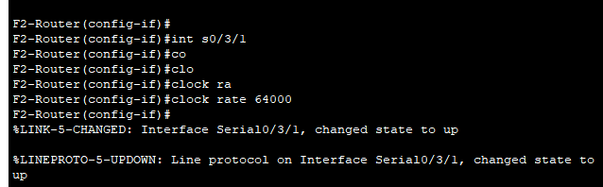

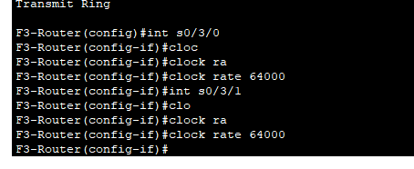

After that we turn First floor end-host into access port and create VLAN to their respective VLAN

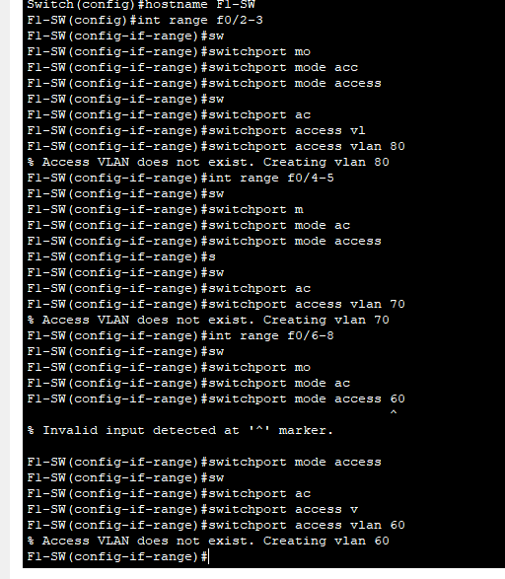

After trunk port for SW connecting to Router link

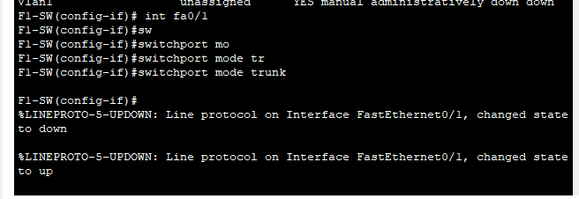

Configure end-host in Second floor into access mode and trunk

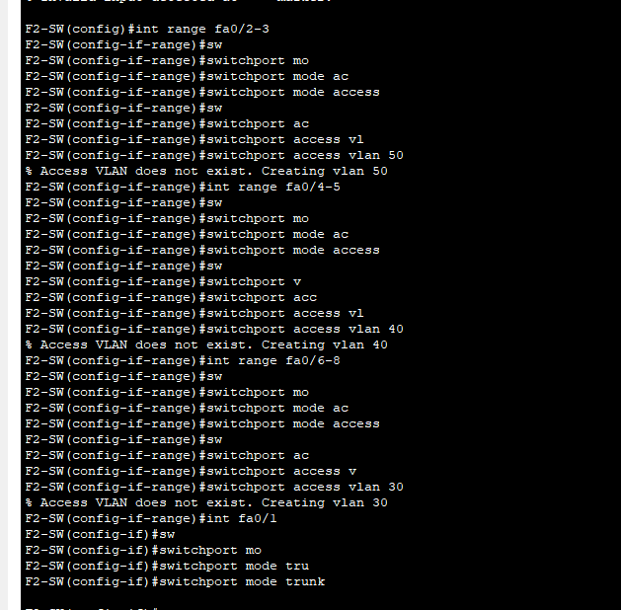

The same goes to Third Floor interface VLAN

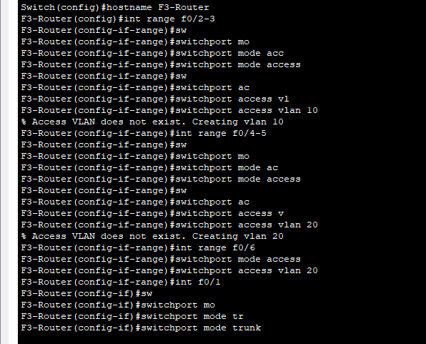

After that we configure 3 Router with their respective subnet and usable IP range

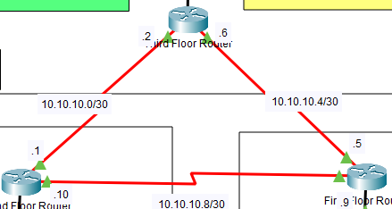

After settings up the IP in the Router, we will continue with configuring for the Inter-VLAN routing

First Floor Router

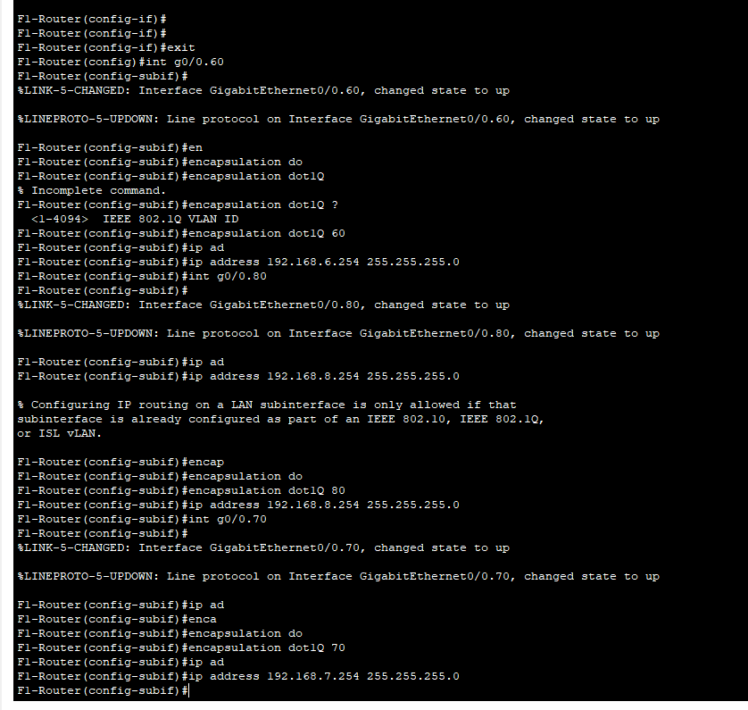  
With this command, I assigned with the last usable IP of each VLAN

F1-Router(config)#int g0/0.60  
F1-Router(config-subif)#encapsulation dot1Q 60  
F1-Router(config-subif)#ip address 192.168.6.254 255.255.255.0

F1-Router(config)#int g0/0.70  
F1-Router(config-subif)#encapsulation dot1Q 70  
F1-Router(config-subif)#ip address 192.168.7.254 255.255.255.0

F1-Router(config)#int g0/0.80  
F1-Router(config-subif)#encapsulation dot1Q 80  
F1-Router(config-subif)#ip address 192.168.8.254 255.255.255.0

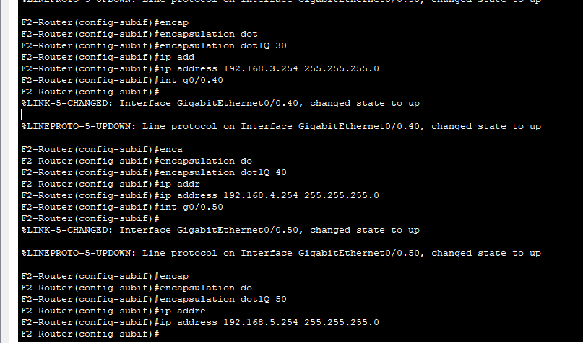

F2-Router(config)#int g0/0.30

F2-Router(config-subif)#encapsulation dot1Q 30

F2-Router(config-subif)#ip address 192.168.3.254 255.255.255.0

F2-Router(config-subif)#int g0/0.40

F2-Router(config-subif)#encapsulation dot1Q 40

F2-Router(config-subif)#ip address 192.168.4.254 255.255.255.0

F2-Router(config-subif)#int g0/0.50

F2-Router(config-subif)#encapsulation dot1Q 50

F2-Router(config-subif)#ip address 192.168.5.254 255.255.255.0

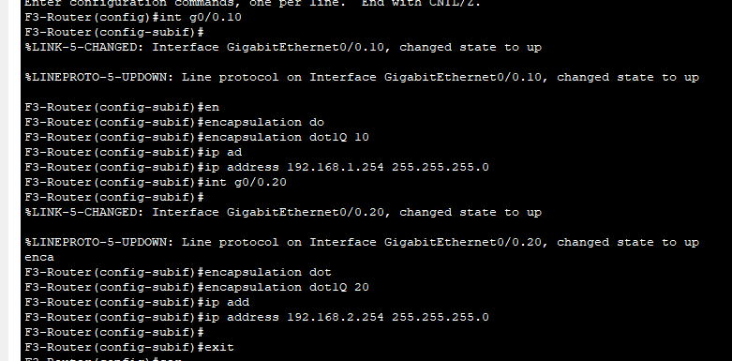

F3-Router(config-subif)#int g0/0.10

F3-Router(config-subif)#encapsulation dot1Q 10

F3-Router(config-subif)#ip address 192.168.1.254 255.255.255.0

F3-Router(config-subif)#int g0/0.20

F3-Router(config-subif)#encapsulation dot1Q 20

F3-Router(config-subif)#ip address 192.168.2.254 255.255.255.0

We configure DHCP service on the Routers

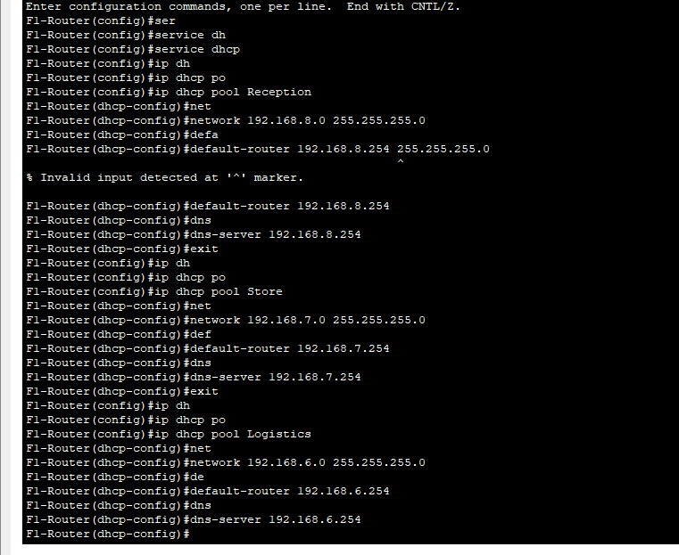

F1-Router(config)#service dhcp

F1-Router(config)#ip dhcp pool Reception

F1-Router(dhcp-config)#network 192.168.8.0 255.255.255.0

F1-Router(dhcp-config)#default-router 192.168.8.254

F1-Router(dhcp-config)#dns-server 192.168.8.254

F1-Router(dhcp-config)#exit

F1-Router(config)#ip dhcp pool Store

F1-Router(dhcp-config)#network 192.168.7.0 255.255.255.0

F1-Router(dhcp-config)#default-router 192.168.7.254

F1-Router(dhcp-config)#dns-server 192.168.7.254

F1-Router(dhcp-config)#exit

F1-Router(config)#ip dhcp pool Logistics

F1-Router(dhcp-config)#network 192.168.6.0 255.255.255.0

F1-Router(dhcp-config)#default-router 192.168.6.254

F1-Router(dhcp-config)#dns-server 192.168.6.254

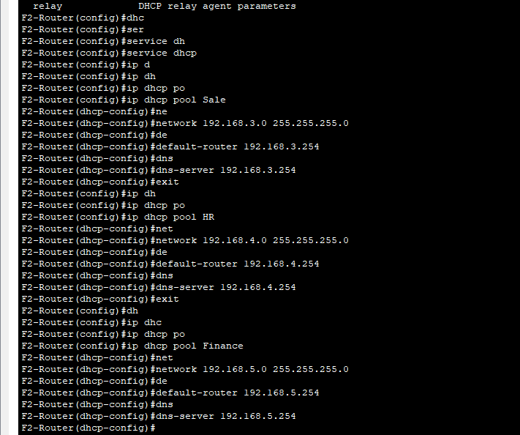

F2-Router(config)#service dhcp

F2-Router(config)#ip dhcp pool Sale

F2-Router(dhcp-config)#network 192.168.3.0 255.255.255.0

F2-Router(dhcp-config)#default-router 192.168.3.254

F2-Router(dhcp-config)#dns-server 192.168.3.254

F2-Router(config)#service dhcp

F2-Router(config)#ip dhcp pool HR

F2-Router(dhcp-config)#network 192.168.4.0 255.255.255.0

F2-Router(dhcp-config)#default-router 192.168.4.254

F2-Router(dhcp-config)#dns-server 192.168.4.254

F2-Router(config)#service dhcp

F2-Router(config)#ip dhcp pool Finance

F2-Router(dhcp-config)#network 192.168.5.0 255.255.255.0

F2-Router(dhcp-config)#default-router 192.168.5.254

F2-Router(dhcp-config)#dns-server 192.168.5.254

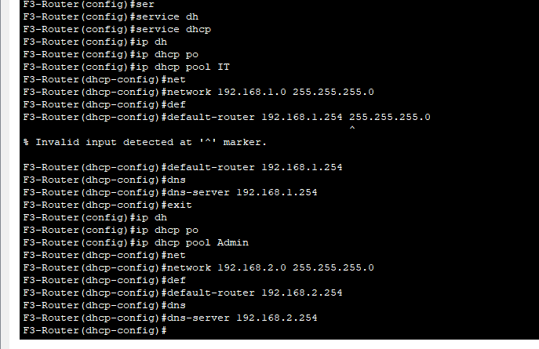

F3-Router(config)#ip dhcp pool IT

F3-Router(dhcp-config)#network 192.168.1.0 255.255.255.0

F3-Router(dhcp-config)#default-router 192.168.1.254

F3-Router(dhcp-config)#dns-server 192.168.1.254

F3-Router(config)#ip dhcp pool Admin

F3-Router(dhcp-config)#network 192.168.2.0 255.255.255.0

F3-Router(dhcp-config)#default-router 192.168.2.254

F3-Router(dhcp-config)#dns-server 192.168.2.254

Configuring OSPF routing in each Router

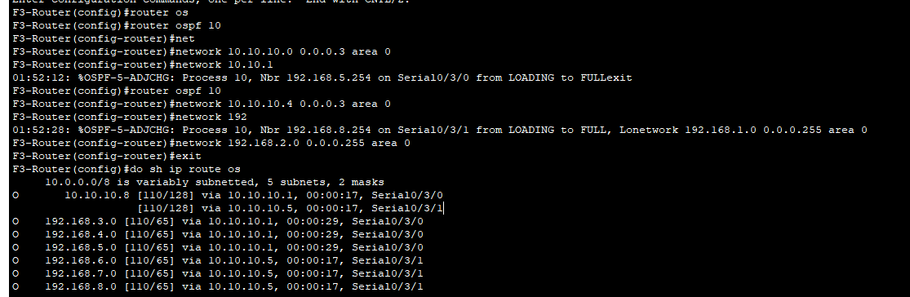

F3-Router(config)#router ospf 10

F3-Router(config-router)#network 10.10.10.0 0.0.0.3 area 0

F3-Router(config-router)#network 10.10.10.4 0.0.0.3 area 0

F3-Router(config-router)#network 192.168.1.0 0.0.0.255 area 0

F3-Router(config-router)#network 192.168.2.0 0.0.0.255 area 0

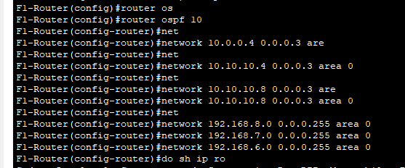

F1-Router(config)#router ospf 10

F1-Router(config-router)#network 10.10.10.4 0.0.0.3 area 0

F1-Router(config-router)#network 10.10.10.8 0.0.0.3 area 0

F1-Router(config-router)#network 192.168.8.0 0.0.0.255 area 0

F1-Router(config-router)#network 192.168.7.0 0.0.0.255 area 0

F1-Router(config-router)#network 192.168.6.0 0.0.0.255 area 0

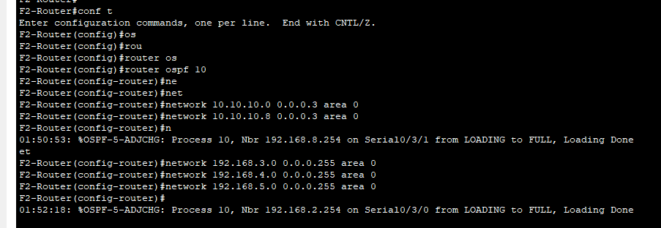

F2-Router(config)#router ospf 10

F2-Router(config-router)#network 10.10.10.0 0.0.0.3 area 0

F2-Router(config-router)#network 10.10.10.8 0.0.0.3 area 0

F2-Router(config-router)#network 192.168.3.0 0.0.0.255 area 0

F2-Router(config-router)#network 192.168.4.0 0.0.0.255 area 0

F2-Router(config-router)#network 192.168.5.0 0.0.0.255 area 0

After done routing

We will try to test out Wireless connection

I added multi Wireless device and setup SSID and Password for access point in each Floor

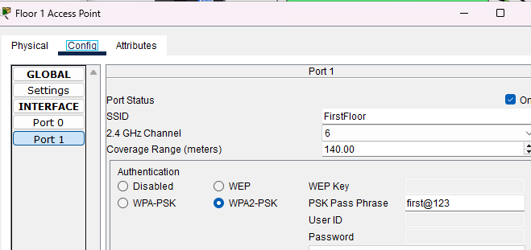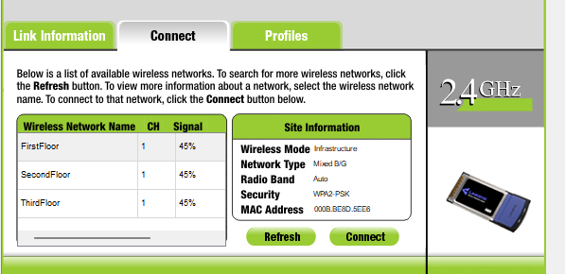

After that we configure SSH

In the third floor router

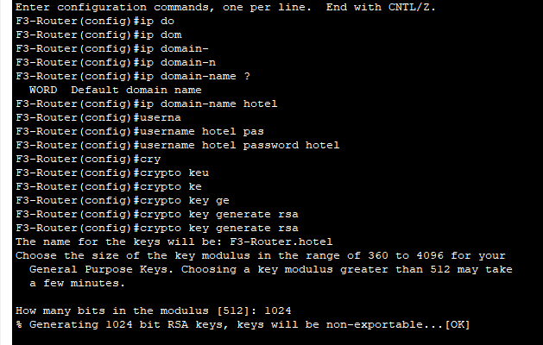

Before configuring SSH we must configure hostname of device and domain name

And configure username and password sine SSH require authentication

Choosing 1024 module is it will use SSHv2

F3-Router(config)#ip domain-name hotel

F3-Router(config)#username hotel password hotel

F3-Router(config)#crypto key generate rsa

F3-Router(config)#line vty 0 15

F3-Router(config-line)#login local

F3-Router(config-line)#transport input ssh

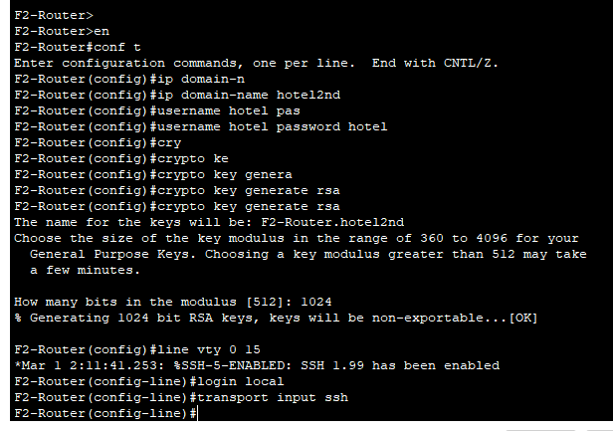

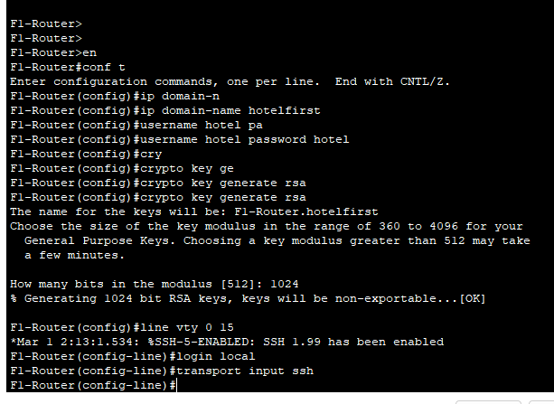

Accessing Second Floor Router and First Floor Router with Hotel as the user we configured

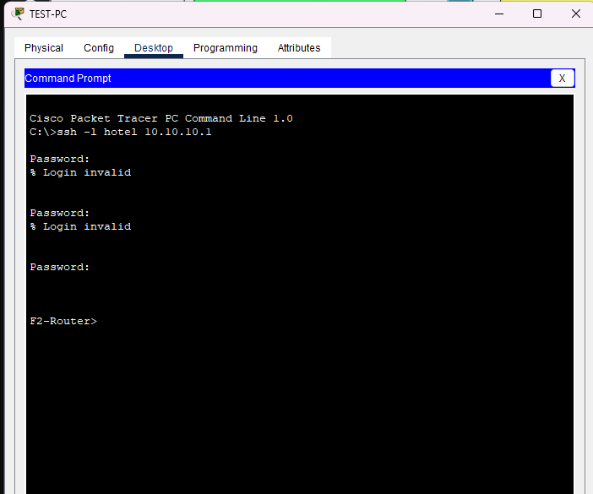

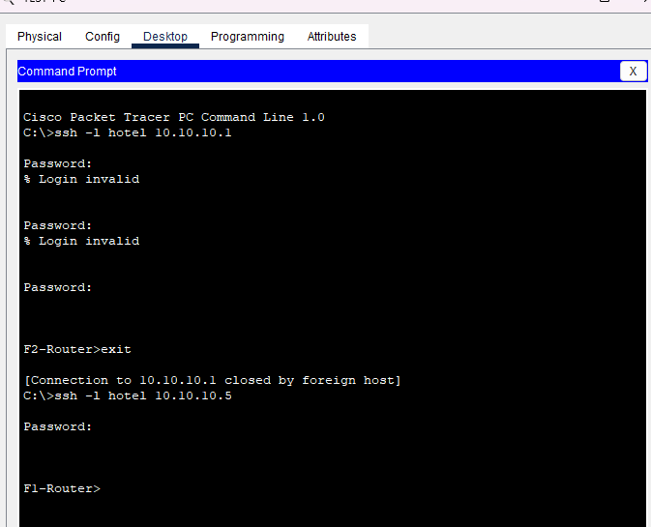

Enable port-security for only the TEST-PC